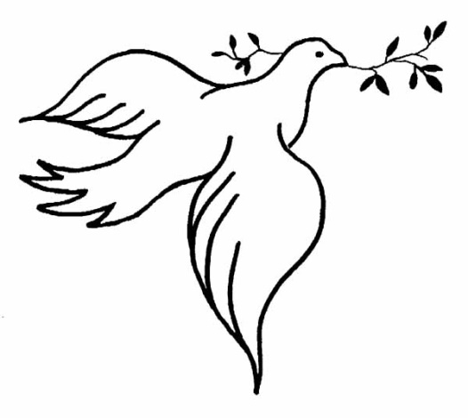
Parents and carers, our whole school theme this term is ‘Community’ and to begin with, we are encouraging the children, throughout the school to think about the subject of Peace.
Although it can be quite a
difficult subject for young children to understand, we are hoping they
will grasp it more as we explore creative activities together.
Look out for the children’s creative work, using hand prints, celebrating togetherness and friendship; making Fig Class a peaceful place to be.

